

STUDENT MANAGEMENT PROJECT
Software Requirement Specification
Group 1

RECORD OF CHANGES
Date | A*  M, D | In charge | Change Description

I. Overview

1. Introduction
Television Online Shop - SWP391's online TV sales system. Tn this system, users will easily find and buy televisions more easily. As for store owners, they will easily manage, sell TV and view sales statistics more easily.
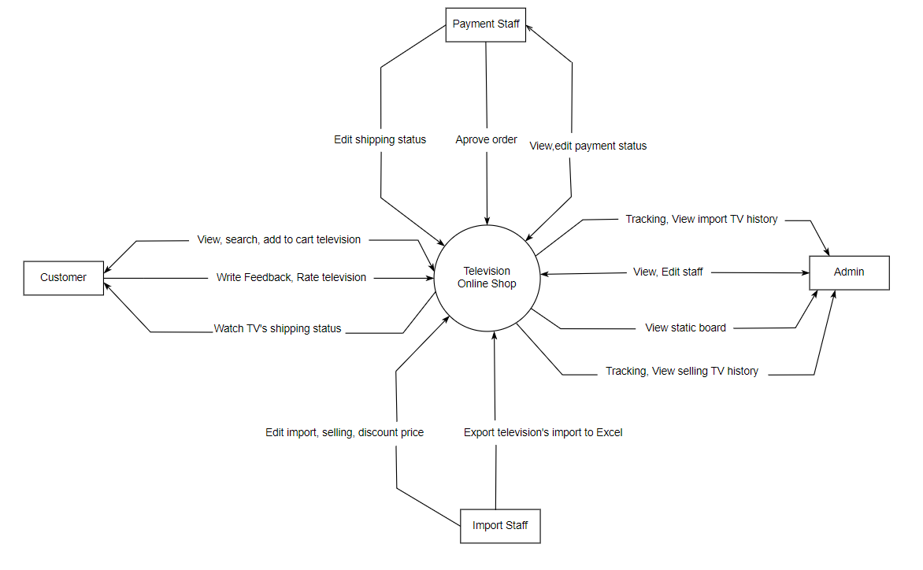

2. System Functions

a. Screen Flow
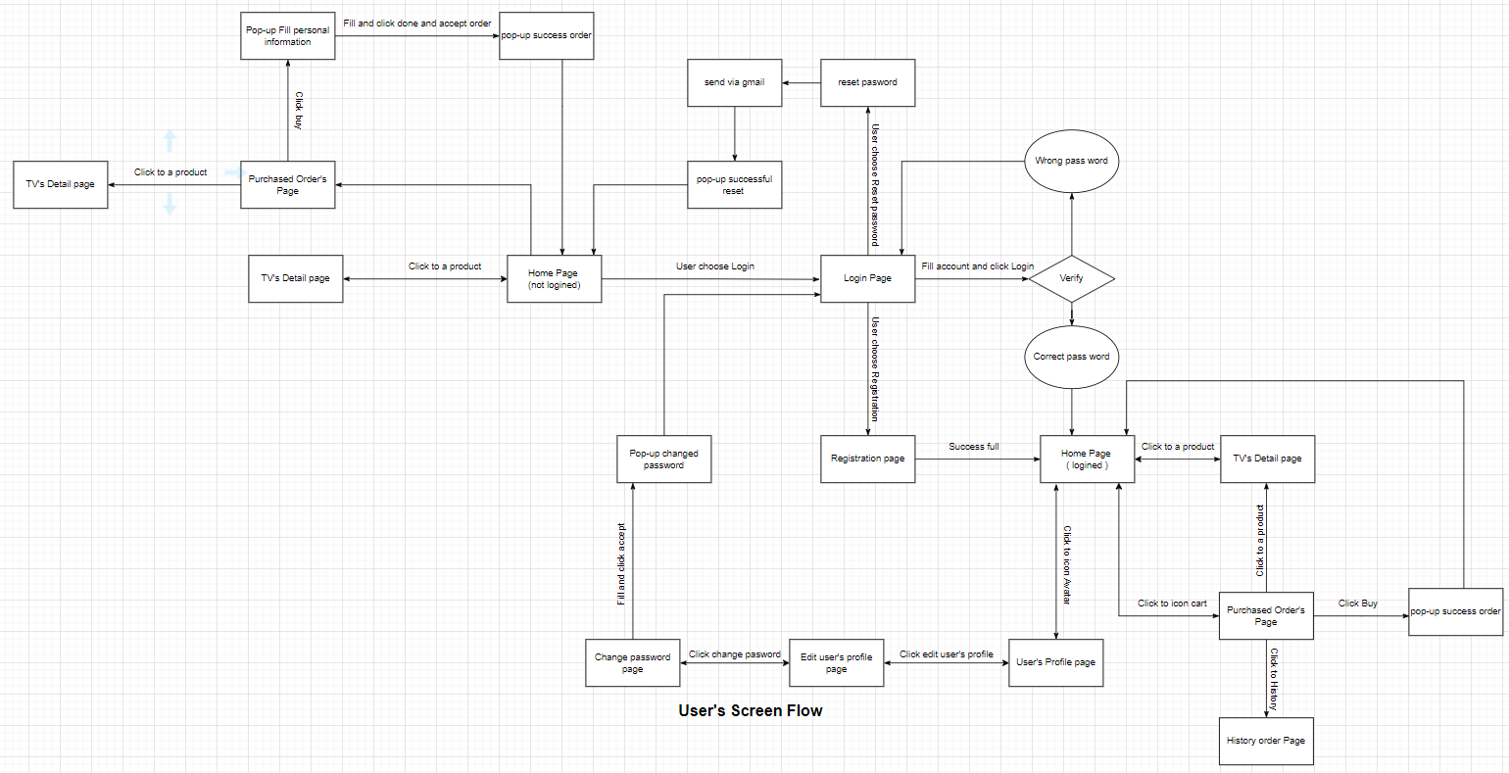

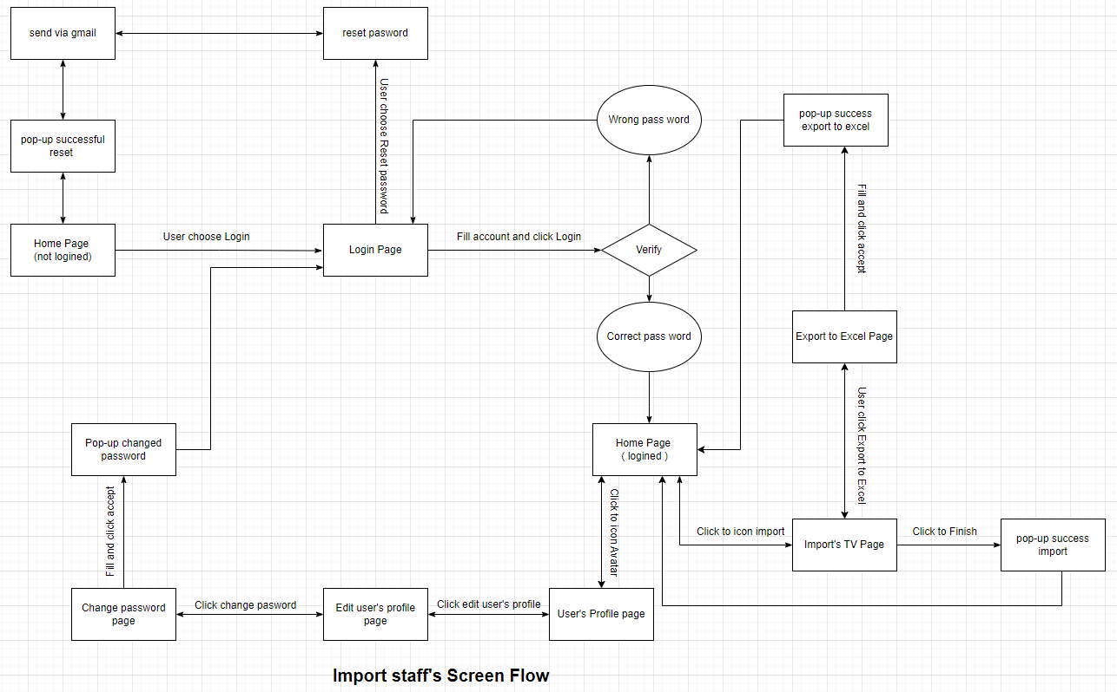
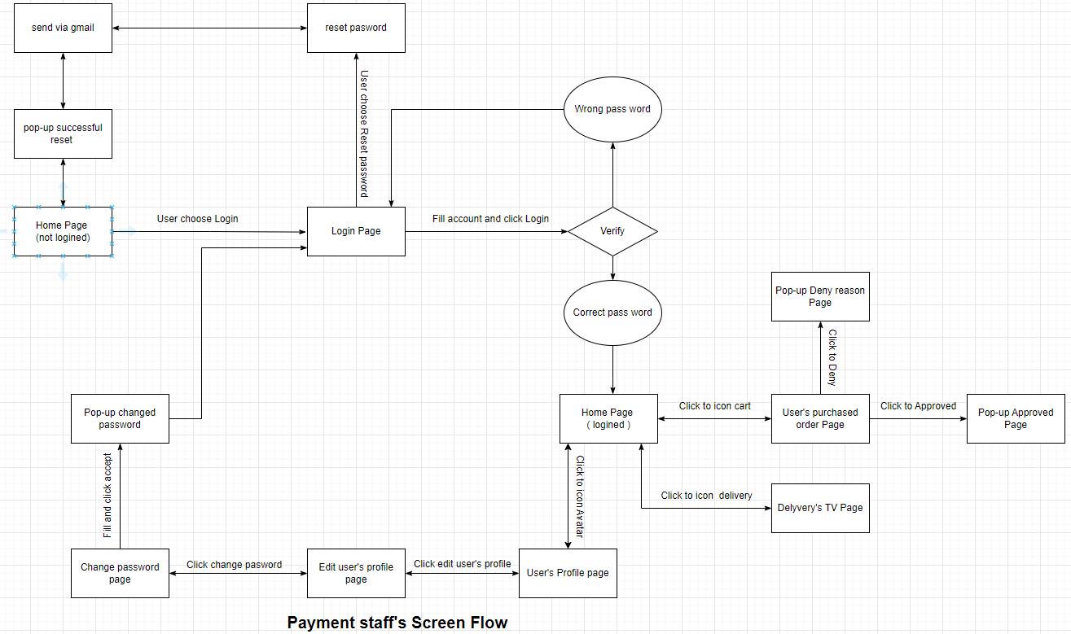

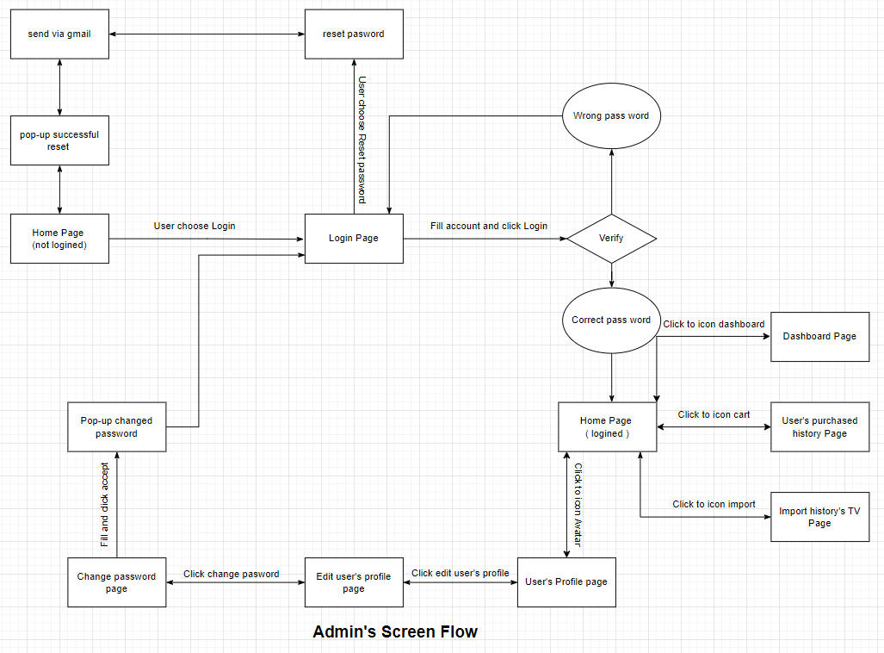

b. Screen Details
No | Feature | Screen | Description
1 | Common | Home Page | View, Search TV by type, price,…
2 | Common | Login | User enter username, password and able to reset password
3 | Common | Register | User register account
4 | Admin | Dashboard | View weekly, monthly, quarterly, yearly statistics
5 | Admin | User's purchased history Page | View user’s purchased history list
6 | Admin | Import history’s Page | View import’s history list
7 | Payment staff | User’s purchased order Page | View, change status (deny, approved)
8 | Payment staff | Delivery’s TV Page | View and change status delivery (pending, shipping, success )
9 | Import staff | Import’s TV Page | View, change status import’s TV list (Finish, not finish)
10 | Import staff | Export to Excel Page | Export import list to Excel
11 | Common | Reset Password | Get account when forgetting the password
12 | Common | User profile | Information of user
13 | Common | Change password | Change password
14 | Common | Purchased Order’s Page | View, Edit, Buy list of chose TV
15 | Common | TV’s Detail Page | View detail of a TV and add to cart
16 | User | History Order Page | View lost of bought TV
17 | Common | Edit profile | View, edit personal profile

c. User Authorization
Screen | Admin | User | Import staff | Payment staff
Dashboard | x
Login
- Login | X | X | X | X
- Reset Password | X | X | X | X
- Register |  | X
User's purchased history Page | X
Import history’s Page | X
Delivery’s TV Page |  |  |  | X
User’s purchased order Page |  |  |  | X
Import’s TV Page |  |  | X
Export to Excel Page |  |  | X
User profile | X | X | X | X
Subject Setting Detail | X | X
Change password | X | X | X | X
Purchased Order’s Page | X | X | X | X
TV’s Detail Page | X | X | X | X
History Order Page |  | X
Edit profile | X | X | X | X
In which:
- Role1: Admin who can view statistic and manage staff, user. Manage of TV shop.
- Role2: User who can able login, View TV products and order TV.
- Role3: Import staff who can control importing TV and can be export list of import TV to excel.
- Role4: Payment staff who can confirm order update shipping status, edit payment status.

d. Non-Screen Functions
Id | Feature | System Function | Description
1 | Change password | Update password of account | When users forget their password, they can change it.
2 | Security System | Protection Information | The system protects students and teachers information.
3 | Real time system | Be access all times | The system must be alway access all times

